**Reading (VIPERS FORM)**

Use this form to record key ideas from reading to prepare for the lessons.  make sure you upload the completed form in TEAMS (Reading section)

|  |  |
| --- | --- |
| Topic you prepared: | Links used: |
| Bitwise operations | [Bitwise Operators In Python And Their Application In Logic Gates | by Vincent Tabora | 0xCODE | Medium](https://medium.com/0xcode/bitwise-operators-in-python-and-their-application-in-logic-gates-1233824b556e) |

Terms: Write any new technical term and their meaning, add more rows if needed.

|  |  |
| --- | --- |
| **Terms** | **Meaning** |

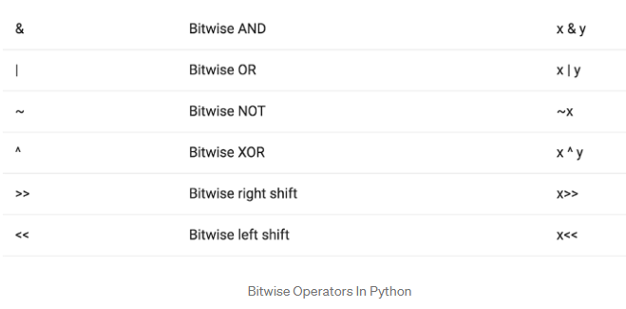

|  |  |
| --- | --- |
| Bitwise Shifting | Move the position of bits either left or right |
| Bitwise shift left | The same as multiplying a number |
| Bitwise shift right | The same as dividing a number. |

|  |
| --- |
| **What can we understand from the topic?** |
| We can do Boolean operations in python allowing us to program hardware. Furthermore, we can create Logic circuits in python. |

|  |
| --- |
| **How this topic linked to other previous topics ? What conclusions can we draw from this topic?** |
| Boolean algebra, logic circuits. Therefore, this topic is the use of Booleans in python using the same rules and information as in the previous topic (Booleans/logic gates) |

|  |
| --- |
| **What are the strengths / applications of this topic? (e.g. accuracy, steps of calculations, time or space complexity, used when …., hardware and software needs, ethical or legal issues, ….etc.)** |
| A strength is that we can produce hardware and software for the computer since computers only function in binary. |

|  |
| --- |
| **What are the limitations / drawbacks of this this topic (e.g. problems, limited accuracy, too many steps, too complex, cannot be used when, hardware requirements, ethical and legal issues, ….. etc.)** |
| It can only be used with binary numbers as Boolean operations don’t work with denary numbers. |

.

|  |
| --- |
| **Write a summary of the topic in 50 words** |
| To summarise, we can create logic circuits with the use of Boolean algebra in the form of bitwise operators. This allows the us to do everything Booleans can do in programs such as python. This can be used to create hardware for the computer as well as software programs when needed. |